Onyx

February 2017

Upgrade Procedures
Version 7.8

Copyright © 2014 Aptean. All Rights Reserved. The information provided by Aptean in this document is for informational purposes only, without representation or warranty of any kind, and Aptean shall not be liable for errors or omissions with respect to the information. The only warranties for Aptean products and services are those set forth in the express warranty statements accompanying such products and services, if any, and nothing herein shall be construed as constituting an additional warranty. No part of this document shall be reproduced or transmitted in any form or for any purpose without the express written permission of Aptean. The information contained herein may be changed without prior notice. Some products marketed by Aptean contain proprietary software components of other software vendors. Aptean and other Aptean products and services referenced herein as well as their respective logos are registered trademark or trademarks of Aptean or its affiliated companies.
Copyright © 2017 Aptean. All Rights Reserved. The information provided by Aptean in this document is for informational purposes only, without representation or warranty of any kind, and Aptean shall not be liable for errors or omissions with respect to the information. The only warranties for Aptean products and services are those set forth in the express warranty statements accompanying such products and services, if any, and nothing herein shall be construed as constituting an additional warranty. No part of this document shall be reproduced or transmitted in any form or for any purpose without the express written permission of Aptean. The information contained herein may be changed without prior notice. Some products marketed by Aptean contain proprietary software components of other software vendors. Aptean and other Aptean products and services referenced herein as well as their respective logos are registered trademark or trademarks of Aptean or its affiliated companies.

Contents

ONYX 7.7 to 7.8 Upgrade Procedures 2
Upgrading OEDB 2
Before you Begin 2
Determine Tables with Foreign Key Relationship on Country_Code 3
Updating the Database 4
Pre-Installation Tasks 5
Upgrading OEDB 6
Post-Installation Tasks 11
Country_Code Changes 11
Onyx Enterprise Dictionary from version 7.7 to version 7.8 12
Troubleshooting 16
OED Upgrade 16
OEDB Upgrade 16

ONYX 7.7 to 7.8 Upgrade Procedures
This section explains the procedures to upgrade:

- Onyx Enterprise Database (OEDB) from version 7.7 to version 7.8
- Onyx Enterprise Dictionary (OED) from version 7.7 to version 7.8
Upgrading OEDB
Important: The database to be upgraded must be in version 7.7.
Before you Begin
The following country names are modified in the Onyx Transaction Database in Onyx 7.7 or higher. The Country Name From column depicts the earlier names of the countries in the database and the Country Name To column depicts the changed name. Some of the countries are may have two new country records. Such countries are highlighted in the following table.
SL# | Country Name From | Code From | Country Name TO | Code To
1 | East Timor | TP | Timor-Leste | TL
2 | Yugoslavia | YU | Serbia | RS
2 | Yugoslavia | YU | Montenegro | ME
3 | Netherlands Antilles | AN | Bonaire, Saint Eustatius and Saba | BQ
3 | Netherlands Antilles | AN | Curacao | CW
3 | Netherlands Antilles | AN | Sint Maarten | SX
4 | Reunion | RE | Saint Barthelemy | BL
4 | Reunion | RE | Saint Martin | MF
5 | MOLDOVA | MD | The republic of MOLDOVA | MD
6 | Venezuela | VE | The Bolivarian Republic of Venezuela | VE
7 | Bolivia | BO | Bolivia, Plurinational State of | BO
8 | St. Helena | SH | Saint Helena, Ascension and Tristan da Cunha | SH
9 | Libyan Arab Jamahiriya | LY | Libya | LY
10 | Papua New Guinea | PG | Independent State of Papua New Guinea | PG
11 | Somalia | SO | Federal Republic of Somalia | SO

New countries added:
SL# | Country Name TO | Code To
1 | South Sudan | SS
2 | The State of Eritrea | ER
3 | Palestine, State of | PS

If your system contains customized database tables that have a Foreign Key relationship to the Country table based on the country_code column, you need to modify these tables before upgrading to Onyx 7.8.

Note: The Foreign Key columns are fixed in the out-of-the-box system.
Determine Tables with Foreign Key Relationship on Country_Code
- Open SQL Management Studio.
- Run the following query on the Onyx Transaction Database:
SELECT
f.name as ForiegnKeyName,
OBJECT_NAME(f.parent_object_id) TableName,
COL_NAME(fc.parent_object_id,fc.parent_column_id) ColName
FROM
sys.foreign_keys AS f
INNER JOIN
sys.foreign_key_columns AS fc
ON f.OBJECT_ID = fc.constraint_object_id
INNER JOIN
sys.tables t
ON t.OBJECT_ID = fc.referenced_object_id
WHERE
OBJECT_NAME (f.referenced_object_id) in ('country','region')
and f.name not in (N'fk_region_country', N'fk_address_country',N'fk_country_ml',N'fk_literature_header_country',N'fk_phone_country', N'fk_region_ml',N'fk_address_region',N'fk_literature_order_region')
The above query enables you to determine number of tables that contain foreign key relationship with the country_code column. If number of rows returned is zero, proceed with the upgrade steps.
If there are tables with foreign key relationship, perform the Updating the Database procedure.

Note : If there are multiple foreign key relationships on the same country_code column, in a single table, consider either one of the foreign key not the both.
Updating the Database
- In SQL Management Studio, in the left panel, expand the database, and then expand Tables.
- In the list of table, expand the table that has the Foreign Key relationship.
- Then expand Keys.
- In the list of keys, right-click the foreign key, point to Script Key as, point to Drop And CREATE to, and then click Clipboard. In the figure below an example is illustrated.
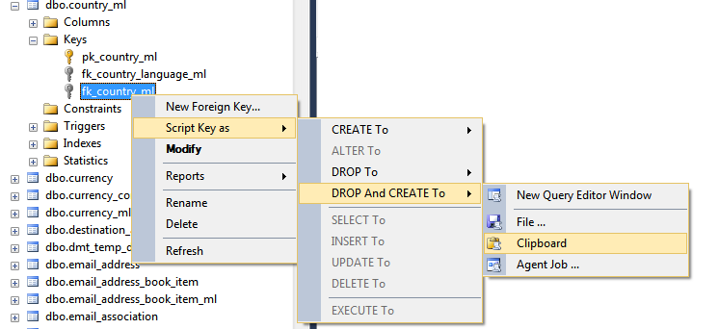
- Open a new Query window and paste the copied query.
- Modify the pasted query by adding ON UPDATE CASCADE as shown in the following example. This SQL statement recreates the foreign key to match the changed country table. For example, in the following script, the foreign key to the country_ml table is modified.
ALTER TABLE [dbo].[country_ml] DROP CONSTRAINT [fk_country_ml]
GO

ALTER TABLE [dbo].[country_ml] WITH CHECK ADD CONSTRAINT [fk_country_ml] FOREIGN KEY([country_code], [site_id])
REFERENCES [dbo].[country] ([country_code], [site_id])
ON DELETE CASCADE
ON UPDATE CASCADE
GO
ALTER TABLE [dbo].[country_ml] CHECK CONSTRAINT [fk_country_ml]
GO
- Repeat steps 1 to 6 for all of the tables that have a foreign key relationship with the changed country table.
Pre-Installation Tasks
- If the database is restored to a different server, run ..\Customization Support\Database Server\Demo Database\ModifyDBOPermissions.sql on the OEDB database.
- In SQL Server Management Studio open ..\utilities\Database Setup Script\DbaSetupScript.sql.
/* CONFIGURATION SECTION ****************************************
-- Edit the following set statements to the names you want to use
-- then log in as sa and run this script in the MASTER database
*/

SET @database = N'OEDB'
SET @onyxDBO = N'onyxDBO'
/* End of configuration section
*****************************************************************
*/
Specify parameters as follows:
@database is the name of Onyx Transaction databse.
@OnyxDBO is the name of OnyxDbo user.
- Run the script.
Upgrading OEDB
Important: Make sure the Microsoft SQL Server service is running before starting to upgrade.
- From the Onyx installed location, navigate to Platform Components > Database Server > Setup.
- On the computer hosting the Database Server, run oedb.exe.
The Welcome window appears.
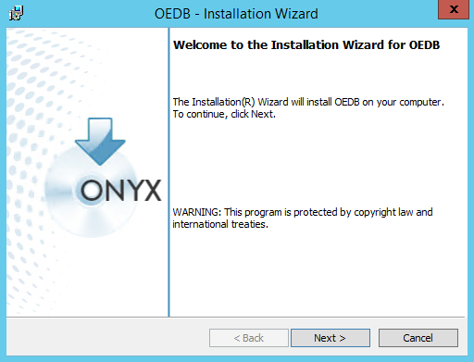
- Click Next.
The Database Information window appears.
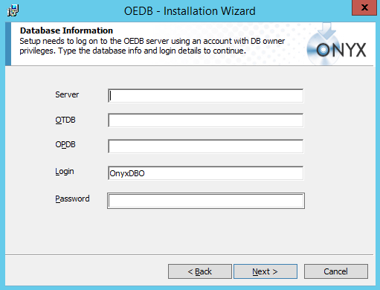
- Do the following:
- Server: Type the name of the SQL Server instance to connect to.
- OTDB : Type the onyx transaction database name.
- OPDB: Type the name of persistencedb database
- Login: Retain the default user name for the database owner account, or type a different name.
- Password: Type the password for the OEDB database owner account.
- Click Next.
Your connection to the SQL Server is validated and the Onyx SA User Database Information window appears.
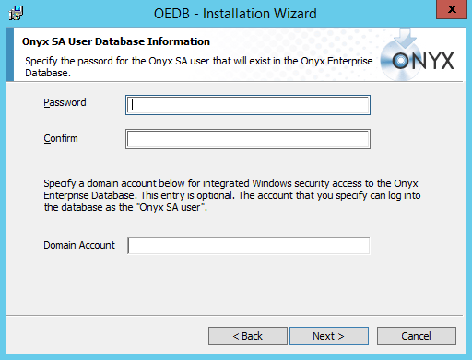
- Do the following:
- Password: Type a password for the Onyx administrator account.
- Confirm: Repeat the password.
- Domain Account: If you plan to use Integrated Windows Authentication, type an existing domain account in the format <domain_name\user_name>. This is optional.
Note: Entering a domain account enables Integrated Windows Authentication for any Onyx product that uses the application server. For more information, see the Windows Authentication website.

- Click Next.
The List Manager Account window appears.
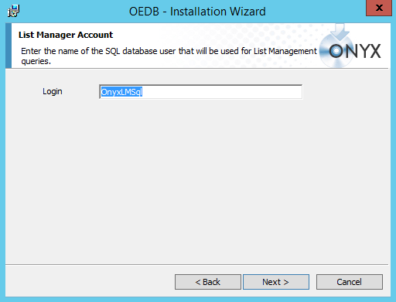
- Retain the default user name for List Management queries or type a different name.
- Click Next.
The Ready to Install the Program window appears.
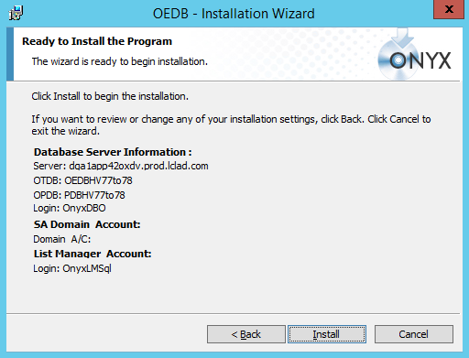
- Verify that the information displayed is accurate.
- Click Back to change any of the previously entered information if required.
OR
Click Install to begin the database configuration process.
- Click Close when the status box displays shows that the process is complete.
The Setup Complete window appears.
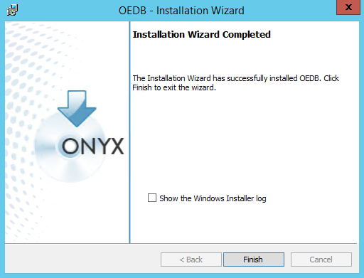
- Click Finish.
Caution:
- If you are unable to complete the configuration and need to restart the OEDB Setup, do not reuse the same databases. You can create fresh databases with a new name, or you can delete the earlier databases and restore a working backup.
- If you try to use the same databases after a previous failure, you might get a severe error that blocks completion of the database configuration.
Post-Installation Tasks
Country_Code Changes
If you have updated the database to fix the country_code foreign key relationship, perform the following tasks:
- Open the query that was run in Step 6 of Updating the Database procedure, remove Update Cascade.
- Run the query.
- Repeat step 2 for all the tables that have the foreign key relationship.
Onyx Enterprise Dictionary from version 7.7 to version 7.8
To upgrade OED:
Prerequisites:
- OnyxEnterpriseDictionary.xml should have read and write permission
- OnyxEnterpriseDictionaryWC.xml should have read and write permission enabled.
- Run OED Upgrade.exe from \Platform Components\Application Server (OEAS)\UpgradeOED.
- On the OEAS 7.8 server, open the Upgrade OED folder, right-click Setup.exe, and then click Run as Administrator.
The Welcome window appears.
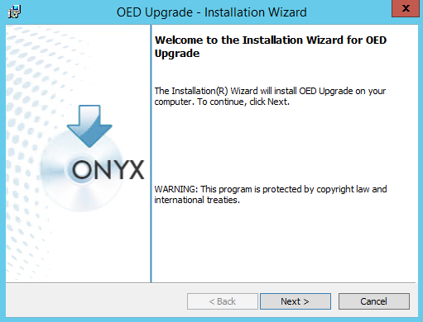
- Click Next.
The Logical Application window appears.
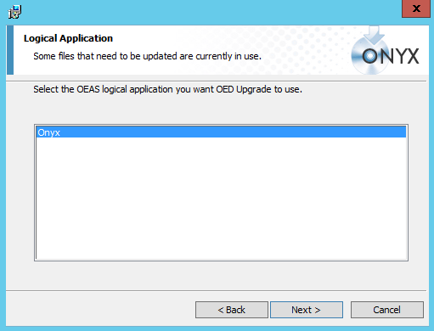
- Select the required OEAS application from the list, and then click Next.
The Ready to Install the Program window appears.
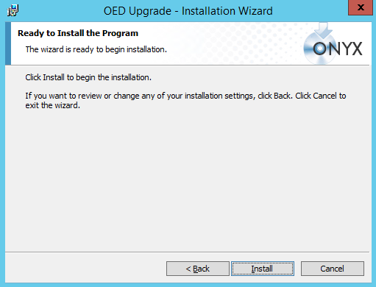
- Click Install.
The Installation Completed window appears.
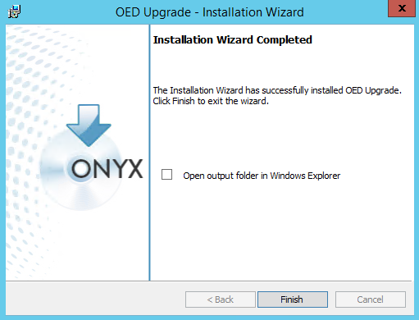
- Click Finish.
- The OED Upgrade utility analyzes your existing Onyx Enterprise Dictionary and creates a new folder OED Upgrade Output is created in the default location ..\Program Files\Onyx\AppServer\Applications\Onyx.
- Examine the contents of the OED Output folder. Refer to the Readme.txt file included in the folder to understand each file in the folder.
- Rename the OnyxEnterpriseDictionary_7.8.xml file in the OED Output folder to OnyxEnterpriseDictionaryWC.xml.
- On the server where you have installed OEAS 7.8, create a backup of the OnyxEnterpriseDictionaryWC.xml file. The default file location is ..\Program Files \Onyx\AppServer\Applications\Onyx.
- From the OED Upgrade Output folder on the OEAS 7.8 server, copy the following files to the OEAS 7.7 application directory:
- OnyxEnterpriseDictionaryWC.xml
- OED_upgrade_log.htm
- Open the OED_upgrade_log.htm file in a Web browser and view the upgrade log. This indicates the conflicts found and their resolution for some of the common conflicts.
- Open Object Designer and ensure that all the customizations made in Onyx 7.7 are available in Onyx 7.8.
- Manually resolve any unresolved conflicts found after performing Step-f and Step-g.
- Perform COM + Restart.
- Validate and publish the upgraded OED using the Object Designer publish process. For details about publishing the OED, refer to OEAS 7.8 Technical Reference Guide.
- Perform COM + Restart again and IISReset.
Troubleshooting
OED Upgrade
If MSXML is not installed correctly on the Web/App server, the following error is displayed:
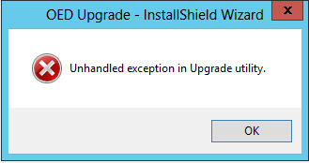
Perform the following steps to resolve the problem:
- Browse to ..\Platform Components\Application Server (OEAS)\Upgrade OED\ISSetupPrerequisites\{6BA446D2-5880-42F4-9C6D-DF7F8C1D3132} folder.
- Run msxml.msi.
- Restart the Web/App computer.
- Run OED Upgrade again.
OEDB Upgrade
During OEDB upgrade an error may prompt that the system is unable to load OSLFEncrypt.dll.
Perform the following steps to resolve this problem:
- Browse to the \Platform Components\Database server\setup\ISSetupPrerequisites\{2075277F-CE13-4B14-8EE7-94973741A89E} folder.
- Run vcredist_x86.exe.
- Restart the database server.
- Perform OEDB upgrade again.

